Christophe Le Bouil
Auckland New Zealand
Email : christophelblc@gmail.com

2012-2016 – GAMELOFT – New Zealand  My work was mainly to implement the game engine features, 3d export tools, game editor, rendering and animation pipeline, and also to help several game release :  Littlest Pet Shop – iOS, Android  - memory reduction  - some custom shader implementation  - build Android version  - bug fixing  My Little Pony – iOS, Android  - help on game engine updates  - bug fixing  Wonder Zoo – iOS, Android  - help on game engine updates  - implemented various debuging features  - improved random level generation  - bug fixing  Ice Age Adventures – iOS  - help on game engine updates  - help on custom shaders implementation  - bug fixing  Ice Age Avalanche – iOS  - implemented the 64 bit version  - help on game engine updates  - bug fixing  Country Friends – iOS  - Responsible of Game Server (C++, linux) and client – server comunication  - help on game engine updates  - bug fixing |  |     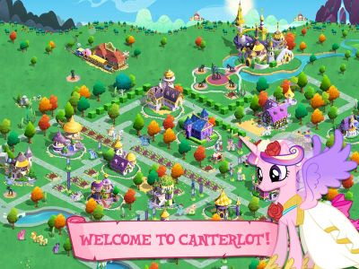        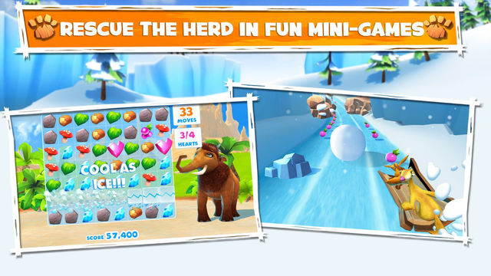  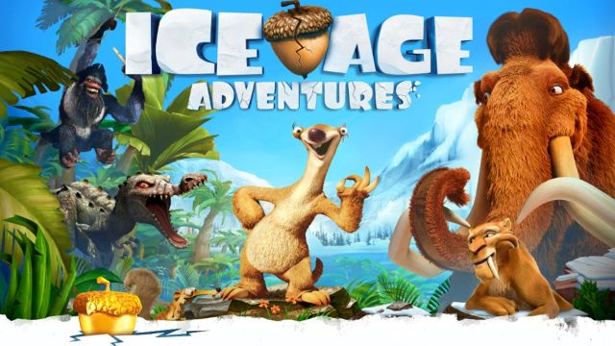    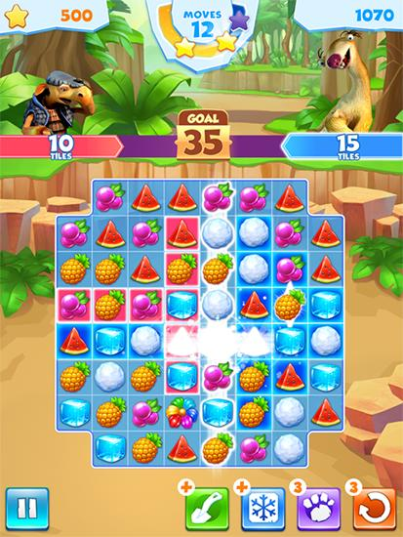    
2011 – AIM AT ENTERTAINMENT – Japan  Space Battleship Yamato Resurrection – Android  2D / 3D exploration / action game  - C++ game engine, interface with java  - 3dsmax conversion tools  Darts Live – Windows custom hardware  Real Darts arcade machine  -Special board hadware communication,  -AI implementation, Action Script |  |   
 | 2006-2011 - ONGAKUKAN  Densha De Go, DS  -3D engine  -3DSMax conversion tool  -PC Viewer tool, for graphic designers  Tetsudu seminar-JR hen, DS  -3D engine for the train mini game  -3D Train track editor  -2D optimized rendering  Rainfan, PS3  -3D engine  -3DSMax conversion tool  Raifan, Taiwan Shinkansen, PS3  -3D engine  -3DSMax conversion tool |  | 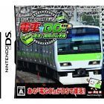  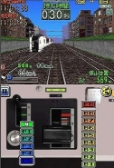  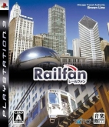  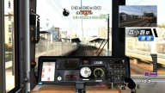  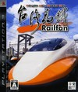  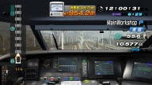  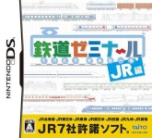  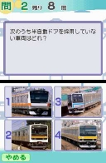

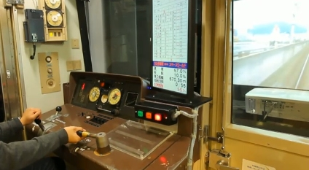  Some Train simulators for Museums, driving Scools, special events – PC based, Windows  Kuyshu Museum, 811 model  -simulator engine  -hardware interface  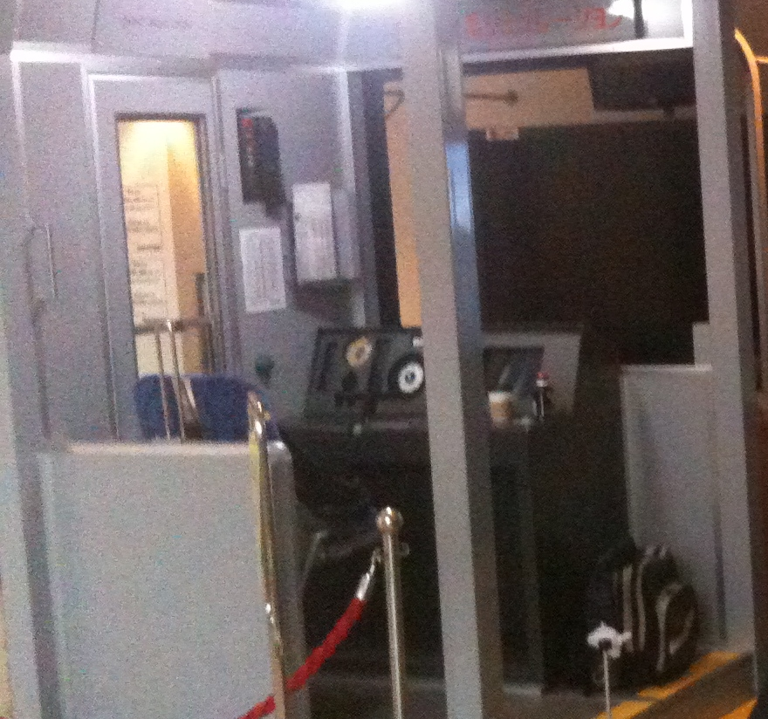  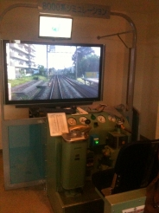  Tokuy museum, 3200 model, 8000 model  -hardware interface  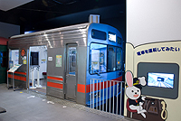  Tokyu museum, 8090 model  -hardware interface |  | 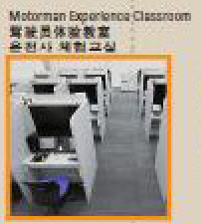  Omiya museum, 25 student cockpits, 1 teacher  -simulator engine  -hardware interface  -network update and synchronisation system  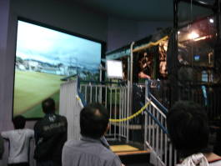    Omiya museum, Steam loco D51, 209, 211 models  -hardware interface  -inter process controller  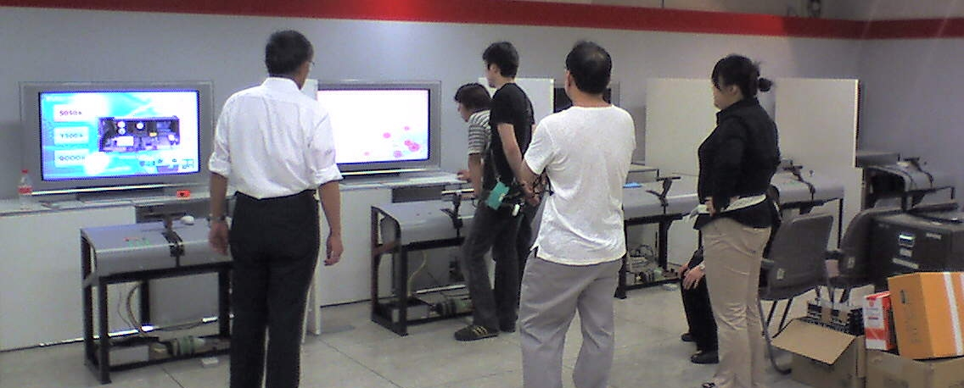  Tokyu departement store, shibuya, golden week event  -hardware interface  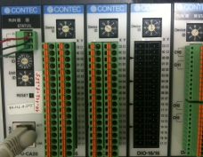  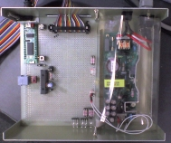  'Zion' custom IO Board - Contec industrial IO devices  Interface systems to communicate with train hardware controllers:  -'Zion' custom board, based on dsPic30F micro controller network (I2C) for digital IO, analog output – USB interface at 1 MB/s  -Contec industrial devices for digital IO, analog IO,  LAN or PCI interface.
2004 –UNICON PRODUCTS Inc. - Japan  EIGO TAMAGO 1, 2 – PC  English learning games  Developed in Flash (Action Script)  Programmer:  -improvement of data management  -bug tracking  -installer (InstallShield)  -BATEN KAITOS - GameCube (NAMCO)  RPG / Card game  Localization:  US & European version from Japanese version  Lead Programmer:  -team management  -localization tools  -debugging tools  -low level modifications for localization  -DOT HACK 1,2,3,4 - PS2, (BANDAI)  RPG / Adventure game  Localization:  European version from US version  Lead Programmer:  -team management  -localization tools  -debugging tools  -low level modifications for localization | 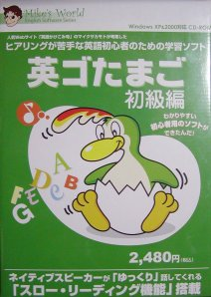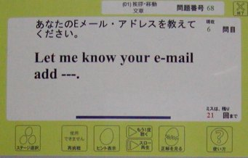  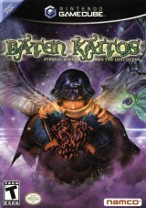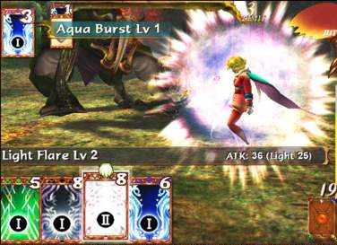  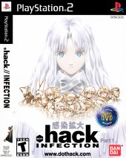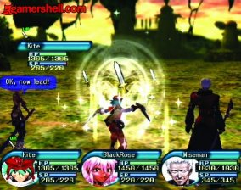

2002 – IDEA FACTORY / Hyper-DevBox - Japan  -GT CUBE - PSP  Racing game  Conversion from GameCube  Main Programmer - Freelance  -2d,3d conversion tools  -low level modifications  -VARANOIR – GameCube  3D RPG game  Conversion from PS2  Main Programmer - Freelance  -2d,3d conversion tools  -low level modifications  -GENERATION OF CHAOS – GameCube  RPG  Conversion from PS2  Main Programmer - Freelance  -2d conversion tools  -low level modifications  -development of new features |   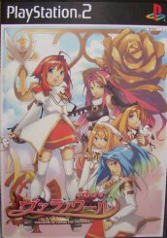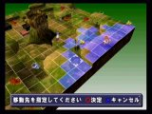  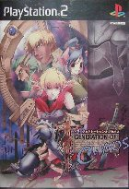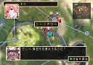

2000 – TOKA - Japan  - SKY SURFER – PS2  3D Sport simulation  Localization :  US & Europe version from Japanese version  Main programmer:  -low level modifications  -development of new features  - SOUL FIGHTER – GameCube  Fighting game  Conversion from PS2  Main programmer:  -low level modifications | 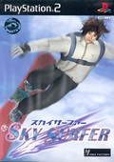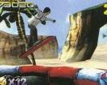  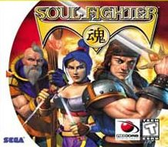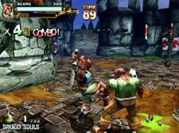

1995 – CRYO INTERACTIVE - France  -GIFT – GameBoy Color  Action game  Programmer  -implementation of some monster AI  -ODYSEE – PC –  2d/3d Adventure game  Programmer  -high level coding  -improvement of low level systems  -ATLANTIS 2 – PC  2D/3D Adventure game  Programmer  -improvement of the scripting engine  -level design tools  -LES VISITEURS - PC  2D/3D Adventure game  Programmer  -high level coding  -puzzle games  -ATLANTIS - Macintosh  2d/3d Adventure game  Conversion from PC  Main Programmer  -low level modifications  -CHINE - Macintosh  Adventure game  Conversion from PC  Main Programmer  -low level modifications  -EGYPTE – Macintosh  Adventure game  Conversion from PC  Main Programmer  -low level modifications  -VERSAILLES – Macintosh  Adventure game  Lead Programmer  -game engine  -ALIENS - Macintosh  Adventure game  Conversion from PC  Main Programmer  -low level modifications | 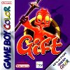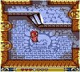  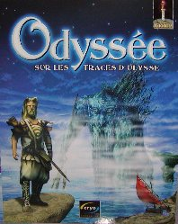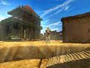  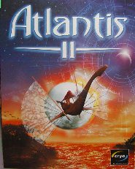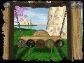  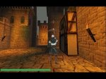  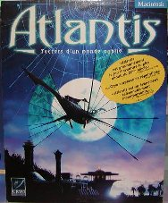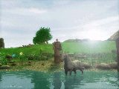  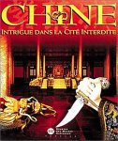  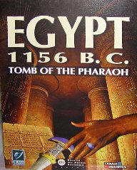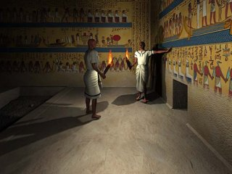  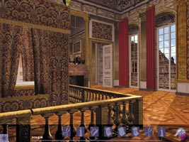  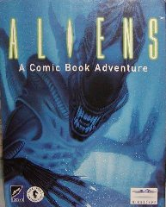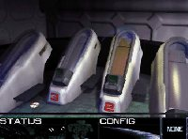

1988 – OCEAN SOFTWARE – France  -IVANHOE – Atari ST  Action game  Main programmer  -game engine  -game tools  -full implementation  - DRAGON NINJA – Atari ST  Action game  Main programmer  -game engine  -game tools  -full implementation | 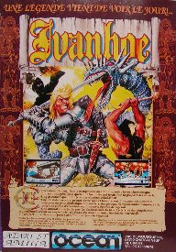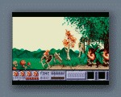  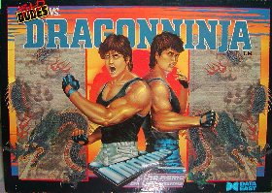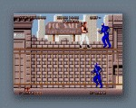

1986 – UBI-SOFT – France  - TRIVIAL PURSUIT – Thomson TO7  Board style game  Conversion from commodore 64  Main programmer  -game engine  - INTERTIE – Amstrad CPC 464  Action game  Game Designer - Main Programmer  -game engine  -full implementation | 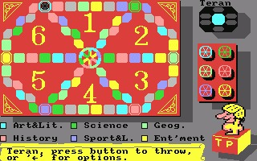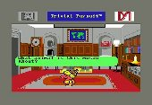  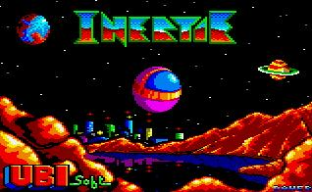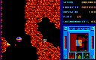

1985 – LORICIEL - France  -MOTO DRIVER – Amstrad CPC 464  Pacman style game  Game Designer - Main Programmer - Freelance  -game engine  -full implementation | 